***CA2 Strategic Thinking***

**Applied machine learning to estimate CO2 adsorption in different materials**

*By*

*Rachel Mae Lademora – 2023396*

*Higher Diploma in Science in Data Analytics for Business*

*Strategic Thinking*

*James Garza*

*CCT College*

*Dublin, Ireland*

CCT College Dublin

**Assessment Cover Page**

|  |  |
| --- | --- |
| **Module Title:** | Strategic Thinking |
| **Assessment Title:** | CA 1 – Capstone Project Proposal |
| **Lecturer Name:** | James Garza |
| **Student Full Name:** | Rachel Mae Lademora |
| **Student Number:** | 2023396 |
|  |  |
|  |  |
|  |  |
|  |  |
| **Assessment Due Date:** | 17th December 2023 |
| **Date of Submission:** |  |

**Declaration**

By submitting this assessment, I confirm that I have read the CCT policy on Academic Misconduct and understand the implications of submitting work that is not my own or does not appropriately reference material taken from a third party or other source. I declare it to be my own work and that all material from third parties has been appropriately referenced. I further confirm that this work has not previously been submitted for assessment by myself or someone else in CCT College Dublin or any other higher education institution.

Table of Contents

Introduction 4

Objectives 5

Problem Definition 5

Scope 5

Data Source 6

Ethical Considerations 6

Appendix 1 7

References 10

# Introduction

Carbon capture and storage have been of extreme importance, as the concentration of this gas has increased, and data has shown that electricity generation will increase by 69% in 2040, with coal-based generation rising by 25% until 2040, achieving high levels of carbon dioxide (CO2) emissions. (Huetteman, Bowman and Slater-Thompson, 2016, p.81; Ren and Liu, 2023, p.1)

The mitigation of CO2 remotion from the atmosphere to reduce the greenhouse effects has become the focus of universities, government, and private institutions; furthermore, developing technologies and products to capture CO2 has gained more power. (Ren and Liu, 2023, p.1). Asif *et al*. (2018, p.4) and Daneshvar *et al*. (2022, p.6) have shown the general panorama of all techniques that we have so far (Figure 1.)

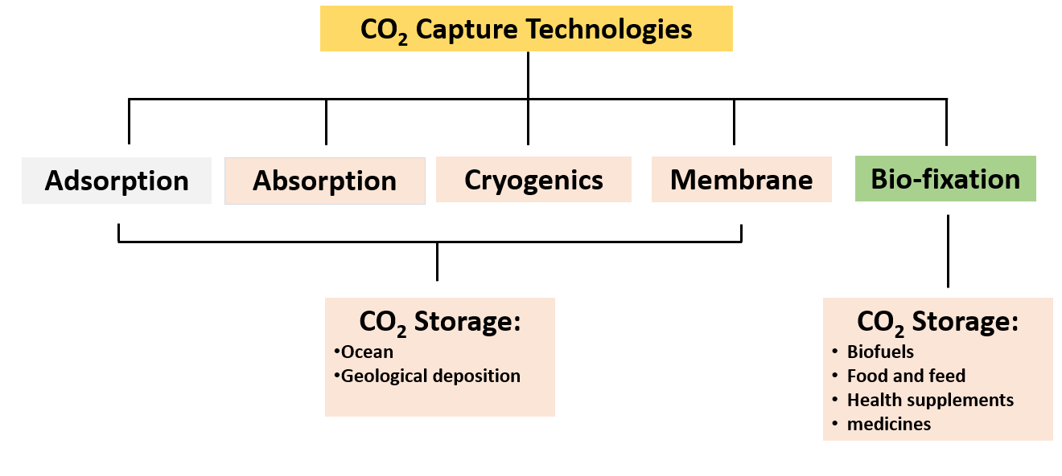

**Figure 1:** Techniques for CO2 capture.

For this capstone project proposal, we will focus on the adsorption technique. This promising method has gained notable attention due to its low operational cost, lower energy demand, ease of handling, and general reliability. (Daneshvar *et al*., 2022, p.4)

Regarding the increase in the technologies to fix CO2, we propose implementing machine learning model to evaluate which one can efficiently estimate CO2 capture. After we obtain our results, it might be possible to understand which material is more efficient and, consequently, which one should be focused on to reduce production costs and become more economically affordable.

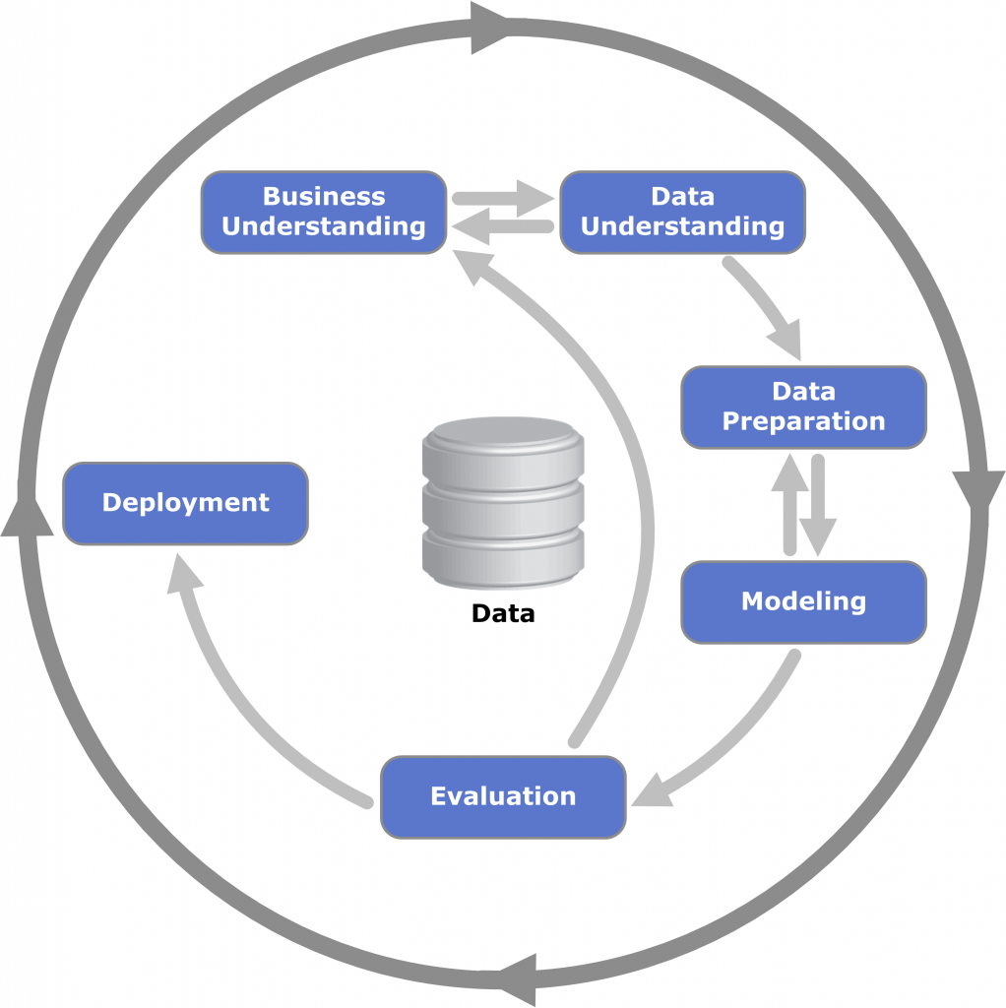

**Business understanding**

In this first phase of the Cross- Industry Standard Process for Data Mining (CRISP-DM) methodology, the ultimate goal is to well understand the business and its needs, which means the objective and the list of requirements to use in this project.

* The principal objective of this project is to propose assessing some machine learning models to predict CO2 adsorption in different materials, such as rice rusk, activated carbons, and carbon nanotubes, considering data from academic papers. The Hypothesis of this project is predicting CO2 adsorption materials using machine learning algorithms to determine the correct accuracy of the materials.

The requirements of this project are:

* Identify the principal materials used in the adsorption technique.
* Use the Exploratory Data Analysis (EDA) to understand the data.
* Apply machine learning models to choose one with a high accuracy score. I would suggest that I will use the low accuracy score of materials to avoid overfitting of the model.
* Implement the chosen ML model to predict CO2 adsorption in these materials.

General Goal:

This project aims to assess some machine learning models to predict CO2 adsorption in different materials. We will give an actual situation of the research in this field, with a compilation of articles analyzed by descriptive statistics. Secondly, we will implement a ML model, such as a decision tree, k-NN, and regression. Probably we will exclude models that would not be interesting to our objective.

The list of important tools and technologies that will be used in the project are:

* List of the Python Libraries:

1. Pandas
2. Numapy
3. Matplotlib
4. Seaboarn
5. Sklearn.model_selection for train_test_split
6. missingno as msno
7. sklearn.experimental import enable_iterative_imputer
8. sklearn import impute
9. sklearn.model_selection import KFold
10. sklearn.model_selection import GridSearchCV

* Modelling: DecisionTreeClassifier- a machine learning model to test using of branching of nodes.

Data Understanding

Data understanding is the second phase of the CRISP-DM Methodology, It means to know about what I have understand to the data.

On this second stage of the CRISP-DM it is crucial to take some time to look every detail of the project data that is stated on the dataset. In order to avoid and encounter some errors when I will proceed to the data preparation. Data preparation is the vital part of the data analysis which is on the third phase of the CRISP-DM methodology. On that part I need to execute the data analysis like cleaning the data which vital before performing the modelling.

Our dataset is based on the academic papers in compiling at least 50 records for materials used in the adsorption CO2 capture technique, and combine this data into an Excel spreadsheet. And the name of our dataset is CO2 adsorption.

As I use the df.head() function, to begin to load the dataset to see the first 5 rows of the dataframe and the 11 columns as visible on the figure 1. And in the conjugated microporous polymers has NAN in the first 5 rows.

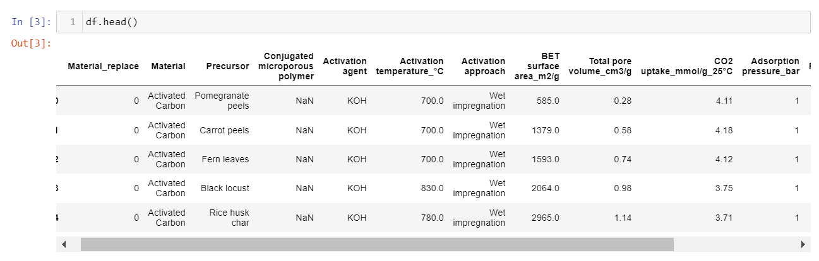

Figure 1. Head of the dataset.

To better understand the dataset this is the data dictionary with definitions and the data type that the CO2 adsorption dataset have.

Data Dictionary

|  |  |  |
| --- | --- | --- |
| Columns name | Definition | Data Types |
| Material Replace | Code for the class material. | Int64 |
| Material | Material used in the CO2 adsorption process. | object |
| Precursor | Is the material used in the initial adsorption process. | object |
| Conjugated microporous polymer | Chemical used in polymers material in the adsorption process. | object |
| Activation Agent | Chemical compound used in the carbon- based material. | object |
| Activation_Temperature_oC | Temperature used to agent activation in carbon-based material. | float64 |
| Activation approach | Technique used in the activation in carbon-based material. | object |
| BET surface area_m2/g | Surface area of the material used in the CO2 adsorption. | float64 |
| Total pore volume_cm3/g | Volume of the pore material used in the CO2 adsorption in 25oC. | float64 |
| CO2 uptake mmol/g_25_ oC | CO2 adsorption in 25oC. | float64 |
| Adsorption pressure_bar | Pressure of CO2 adsorption. | int64 |
| Reference | Reference for academic papers results (Dziejarski et al., 2023, p.69-74). | object |

By using the df.info() function it will visualize the information about the dataframe. This will help me to understand if there are any data incompatibilities, like the unnamed columns. It also identifies the types of attributes in the dataset. There are 6 floats, 2 int64s, and 6 objects. the df.shape function it will visualize the overall counts of the rows and columnd of the C02 adsorption dataset, which have the total rows of 57 and 14 columns.

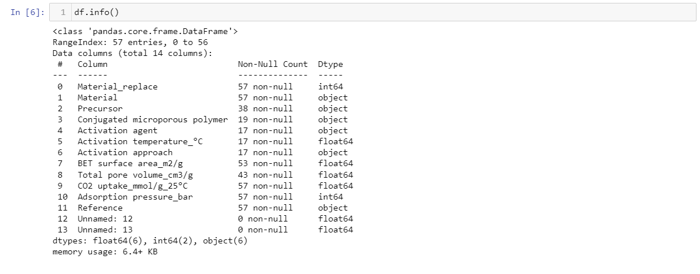

. Figure 2. Shape and info of the dataset.

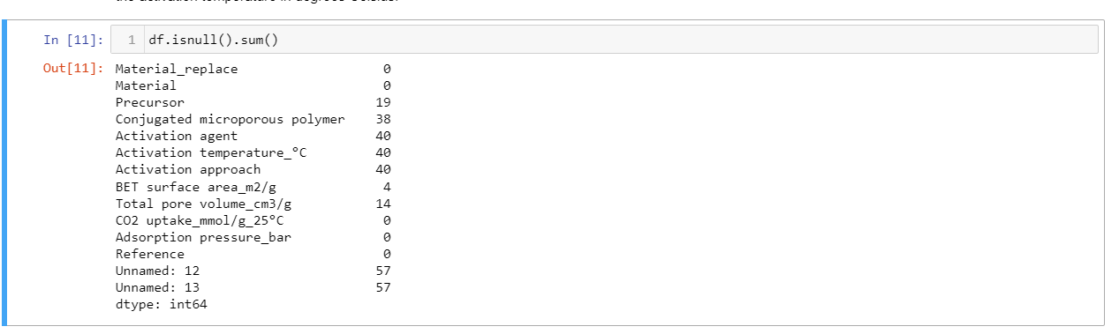

Figure 3 isnull().sum() dataset.

In figure 3 the df.isnull().sum() is used to see the total null values of each column. As stated, there are 0 null values in material replace and material. While the activation approach, activation temperature_°C, and activation agent have 40 null values. And the two unnamed columns has the complete 57 null values and this unnamed columns need to be drop since this is not important to be used in machine learning.

By proceeding to the next step is which is the summary statistics of the dataframe which is the “.describe” function. It is responsible for the central tendency dispersion and the std shows the amount of change in the data and determines how it expands the values that come from the mean. The min shows the values of each column from higher to lower. Also, it helped me understand the numerical columns properly. (pandas.pydata.org, n.d.). As stated in the figure

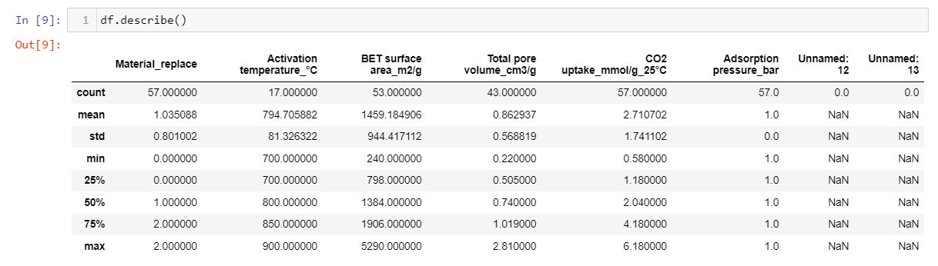

Figure 4. describe of the dataset.

In Figure 4, it is detailed to show the “Material_replace” is capable to find the values with a range of 0.000000 to 2.000000. since the min has a 0.000000 value is low or small it tells that the standard deviation is closer to the mean and not scattered.

As stated on the figure 4, there are two unnamed columns that is not necessary to use for further data analysis, and these two unnamed columns are need to be drop since it has NAN value and this is not useful for machine learning model.

To easily understand the missing values of the CO2 adsorption dataset here are the informative graph that will show the correlation of the missing values of the columns.

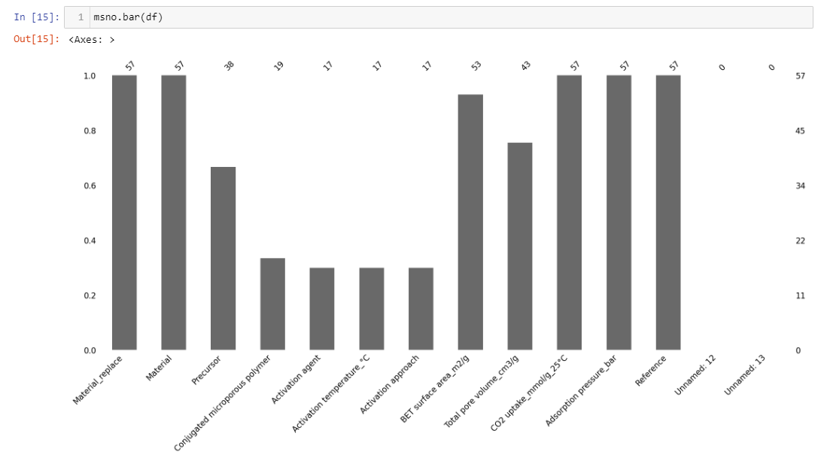

Figure 5 bar graph missing value of dataset.

The dataset of CO2 adsorption has missing values in the bar graph shows that the precursor, conjugated microporous polymers, activation agent, activation temperature_°C, activation approach, and total pore volume (cm3/g) at 25 °C have missing values. The material_replace, material CO2 uptake_mmol/g_25°C, adsorption pressure_bar, and reference have no missing values.

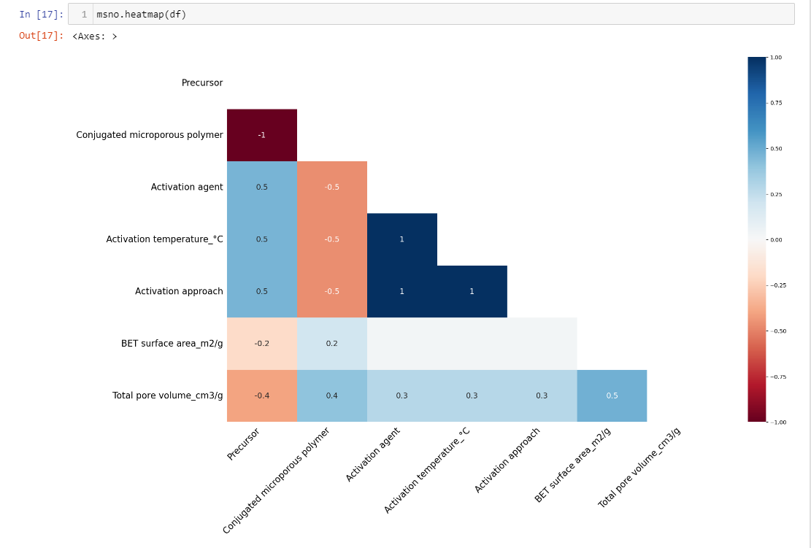

Figure 6 heatmap missing value of dataset.

The heatmap shows the correlations of the missing values of the columns, just like the columns of Bet surface area_m2/g have missing values in the precursor columns. It is vital to illustrate and understand the correlation between the null values of each column. The conjugated microporous polymers have the highest missing values because it has the value of -1.

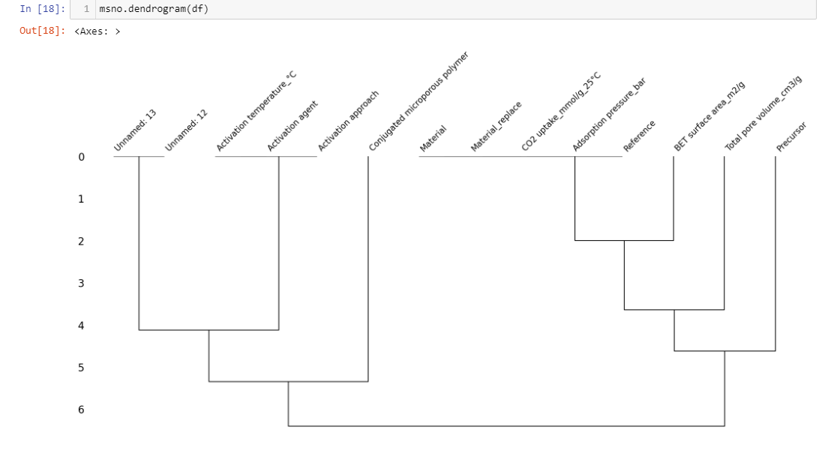

Figure 7 dendrogram missing values of the dataset.

On the right side of the dendrogram, the two unnamed columns have higher missing values than the activation agent columns. The conjugated microporous polymer has the most missing values in the dendrogram. There are also missing values in the adsorption pressure_bar and the BET surface ares_m2/g. The total pore volume cm3/g and the precursor have missing values and are correlated to conjugated microporous polymers.

**Data Preparation**

The third phase is the Data preparation it means that the data cleaning should be implemented on this phase of CRISP-DM Methodology. It requires to fixed the problems of errors of the CO2 adsorption dataset to prepare before l accepting the machine learning models. It has a step that need to be follow like select data, clean the data (missing or outliers), construct the data, integrate the data, and format the data. Some of the data has issues like outliers and missing values. (Saluja, 2018b).

The very important step that need to do in data cleaning is dropping of the columns that is not important to be used for further analysis.

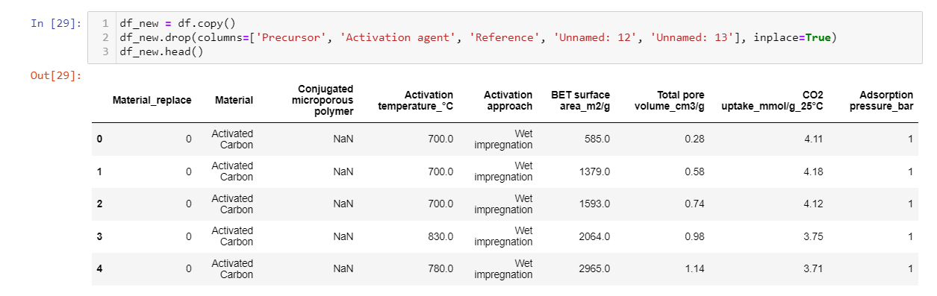

Figure 5. Dropping of the columns of dataset.

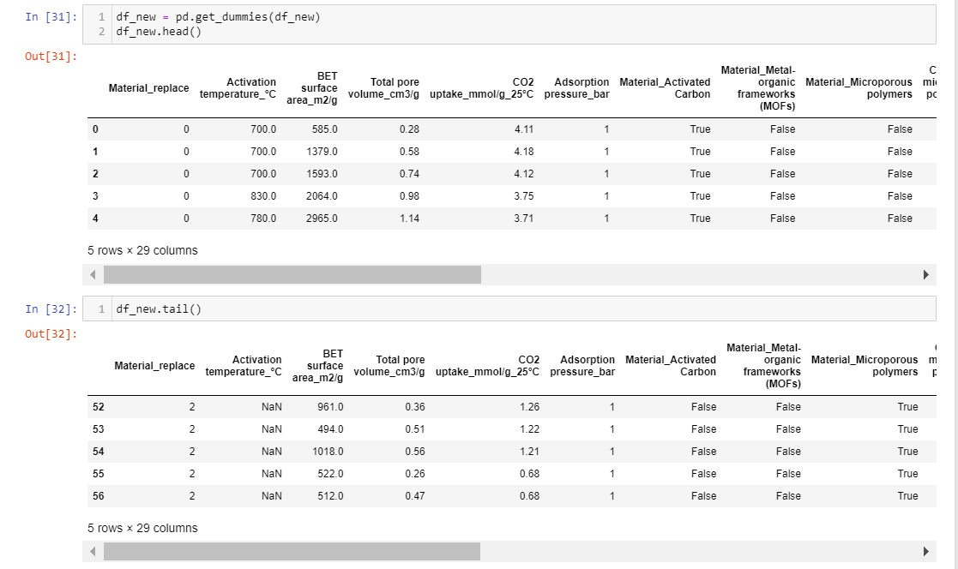

Figure 6. One hot coding

The CO2 adsorption dataset has categorical missing values that is need to transform to numerical variables before performing the machine learning. The one hot coding is a technique that can transform the categorical to numerical variables. Unfortunately, it is not transformed to numerical variables. But I use the iterative imputer to sine it can transform the Boolean true or false to numerical variables.

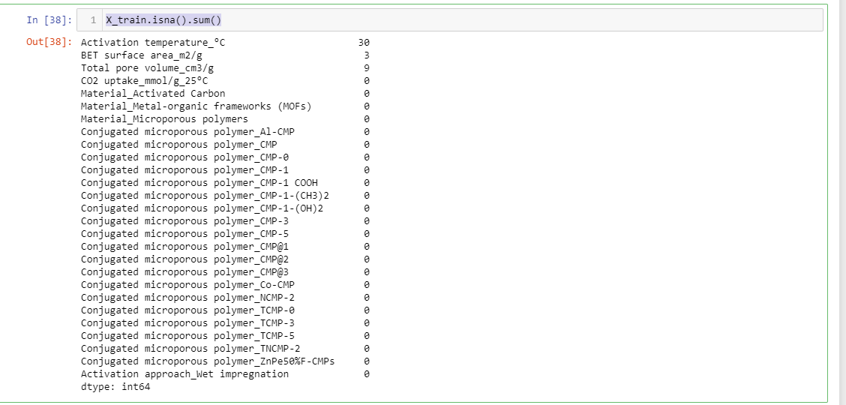

Figure 7A. Iterative imputer.

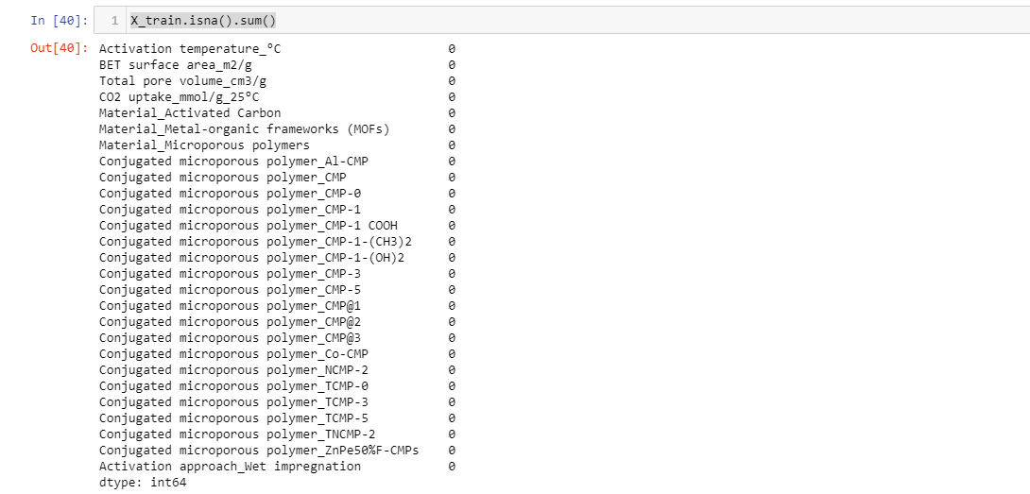

Figure 7B. Iterative imputer.

Appendix 1

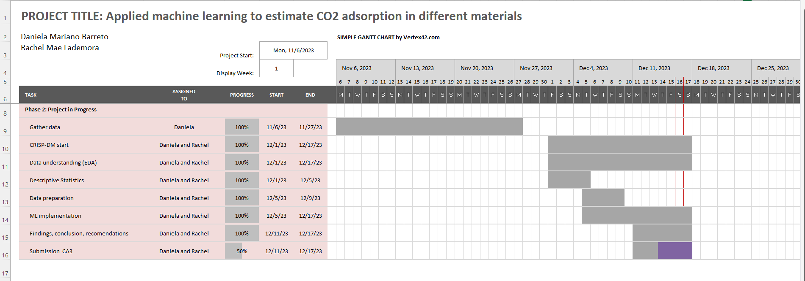

NEW REFENCECE

Saluja, C. (2018b). *Data Preparation — A crucial step in Data Mining*. [online] Medium. Available at: https://medium.com/@chhavi.saluja1401/data-preparation-a-crucial-step-in-data-mining-dba35772f281#:~:text=According%20to%20CRISP%2DDM%2C%20the.

References CA2

Ganji, L. (2019). *ML | One Hot Encoding to treat Categorical data parameters*. [online] GeeksforGeeks. Available at: https://www.geeksforgeeks.org/ml-one-hot-encoding-of-datasets-in-python/.

scikit-learn.org. (n.d.). *6.4. Imputation of missing values — scikit-learn 0.22.2 documentation*. [online] Available at: https://scikit-learn.org/stable/modules/impute.html.

saturncloud.io. (2023). How to Count NaN Values in a Pandas DataFrame Column | Saturn Cloud Blog. [online] Available at: <https://saturncloud.io/blog/how-to-count-nan-values-in-a-pandas-dataframe-column/#:~:text=The%20isna()%20function%20returns> [Accessed 13 Dec. 2023].

[www.w3schools.com](http://www.w3schools.com/). (n.d.). Python dir() Function. [online] Available at: <https://www.w3schools.com/python/ref_func_dir.asp> [Accessed 13 Dec. 2023].